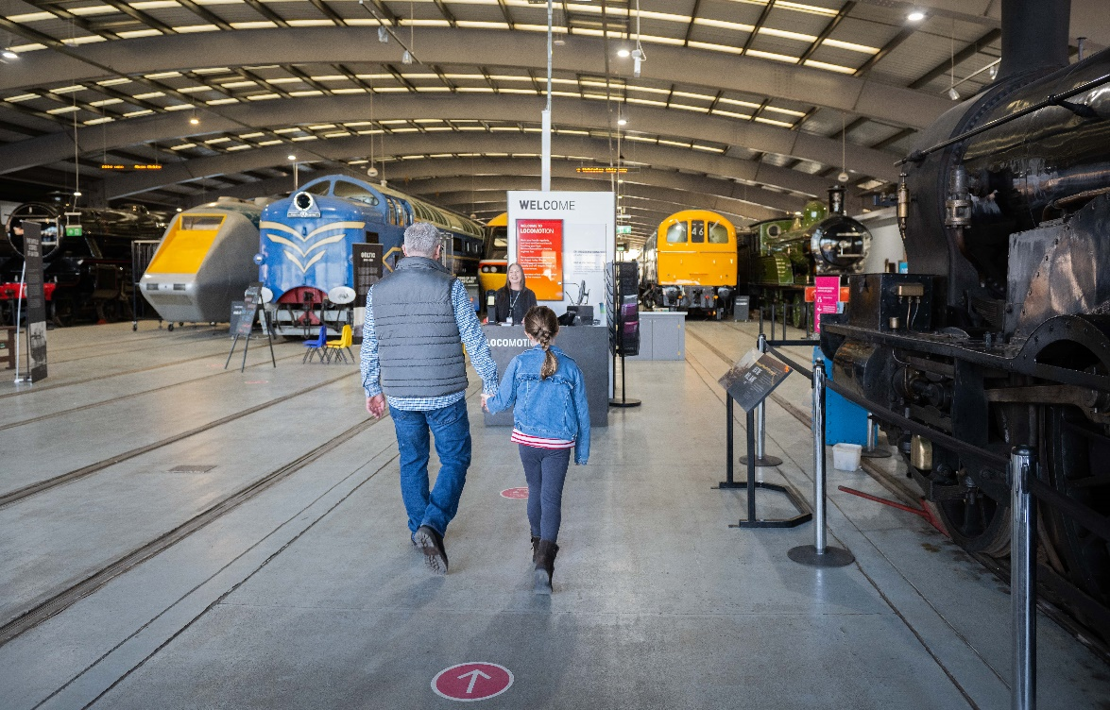
VOLUNTEER VACANCY INFORMATION PACK
VISITOR AMBASSADOR
OUR MISSION AND VALUES:
At Science Museum Group (SMG), we make it our mission to Inspire Futures. Our talented and dedicated colleagues are guided by five values that encapsulate simply what we’re all about:
– We think big, pushing the limits of
what’s possible.
– We challenge ourselves to
reveal wonder.
– We use our passion, expertise and creativity to share authentic
stories.
– We aim to ignite curiosity in our
audiences and our colleagues.
– We take pride in being open for all.

Closing Date: N/A

Interview: N/A

Contents:

About the role
What you bring
How to apply
Support we offer

VISITOR AMBASSADOR

Department: Operations and Events Type: Volunteer Role
Location: Locomotion, Shildon Hours: Flexible
Supervisor: Katrina Ferguson Start Date: Variable

ABOUT THE ROLE:

Our visitor ambassador volunteers play a role in ensuring that all visitors have an enjoyable time with us. You will be the friendly and welcoming face of the museum, sharing the knowledge that you will learn about our collection, facilities, events programme and our visitor journey. In addition to this you will impart updates to visitors around our Vision 2025 plans, including the construction of New Hall. During this exciting time, you will be a part of our welcome team, helping when you can during school holidays, events and weekends.
You will have the opportunity to contribute to both long-term developments and day-to-day operations, helping the museum report on key targets by tracking visitor figures. Your feedback and insights will also influence the ongoing process of creating new models of visitor engagement.
In this role you will operate as part of a supportive team of colleagues, gaining customer service experience and building your confidence in a stimulating environment. Exercising or improving your communication skills, you will help greet visitors, listen and respond to their needs, orientate and direct them, and answer any questions they may have – equipping them with the information that they need to make the most out of their visit.
We ask our welcome volunteers to commit to short sessions of 1-2 hours at a time as often as they are able, and seating can be provided.

WHAT YOU WILL BE DOING:
- You will be the friendly face of the museum, ensuring that all visitors feel welcome
- Assisting with the flow of visitors into the museum
- You will be well informed of all facilities, events and exhibitions taking place in the museum, and actively promote these to enhance visitor experience.
- You will answer visitor queries or seek the assistance of those who can do so.
- Providing feedback and advice on the daily activities of the museum
- As a volunteer you’ll learn about our Health and Safety Policies, procedures, and risk assessments, allowing you to take care of your own personal safety and that of others.

WHAT YOU BRING TO THE TEAM:

- The ability to collaborate with others and join a supportive team of volunteers – potentially helping to mentor and train other volunteers
- Organisational skills that will be utilised when letting your supervisor know your availability
- An ability or willingness to learn a range of information about our museum, the collections, the local area, out events programme and our Vision 2025 plans.
- We ask all our volunteers to show inclusive behaviours, valuing everyone’s contribution, and promoting a culture of openness

You will definitely...
- Be friendly and willing to build your confidence around being approached by and engaging with visitors
- Be enthusiastic about improving visitor experience and sharing your passion for the museum

SOME THINGS YOU NEED TO KNOW:
- To volunteer in this role, you must be 18 or over.
- Volunteers at Locomotion are entitled to claim up to £7 per day they volunteer onsite to cover travel expenses.
- If successful, depending on your role, we’ll request either a basic or enhanced criminal record check. We’ll arrange and process this for you and will cover all the costs.
- Any issues raised in a criminal record check will be considered on a case-by-case basis.
- We are legally required to ensure all volunteers from overseas have the right to volunteer in the UK, so please check your visa before applying.
- SMG is unable to act as a sponsor organisation if you do not have a visa that allows you to volunteer.

HOW TO APPLY!

Interested? We welcome your application. You can apply for this position by emailing katrina.ferguson@sciencemuseum.ac.uk and requesting a Volunteer Application Form.

HOW WE CAN SUPPORT YOU:

- We’d love to hear from you. If you have any questions about the role, please contact Katrina Ferguson (Volunteering Manager) at Katrina.Ferguson@ScienceMuseum.ac.uk
- If you need assistance to complete your application or attend a selection event, for example due to a disability, or would like to talk to us about what we can do to support you through this process, please contact us by email at volunteer@sciencemuseum.ac.uk or by calling 02079424509.
- We are working hard to understand our organisation better and to foster a culture that recognises and values different backgrounds, mindsets, skills, experience, knowledge, and expertise. By having greater diversity, we believe that we will be a stronger and better organisation and ultimately will be able to inspire more futures. We therefore welcome applications from all backgrounds

