

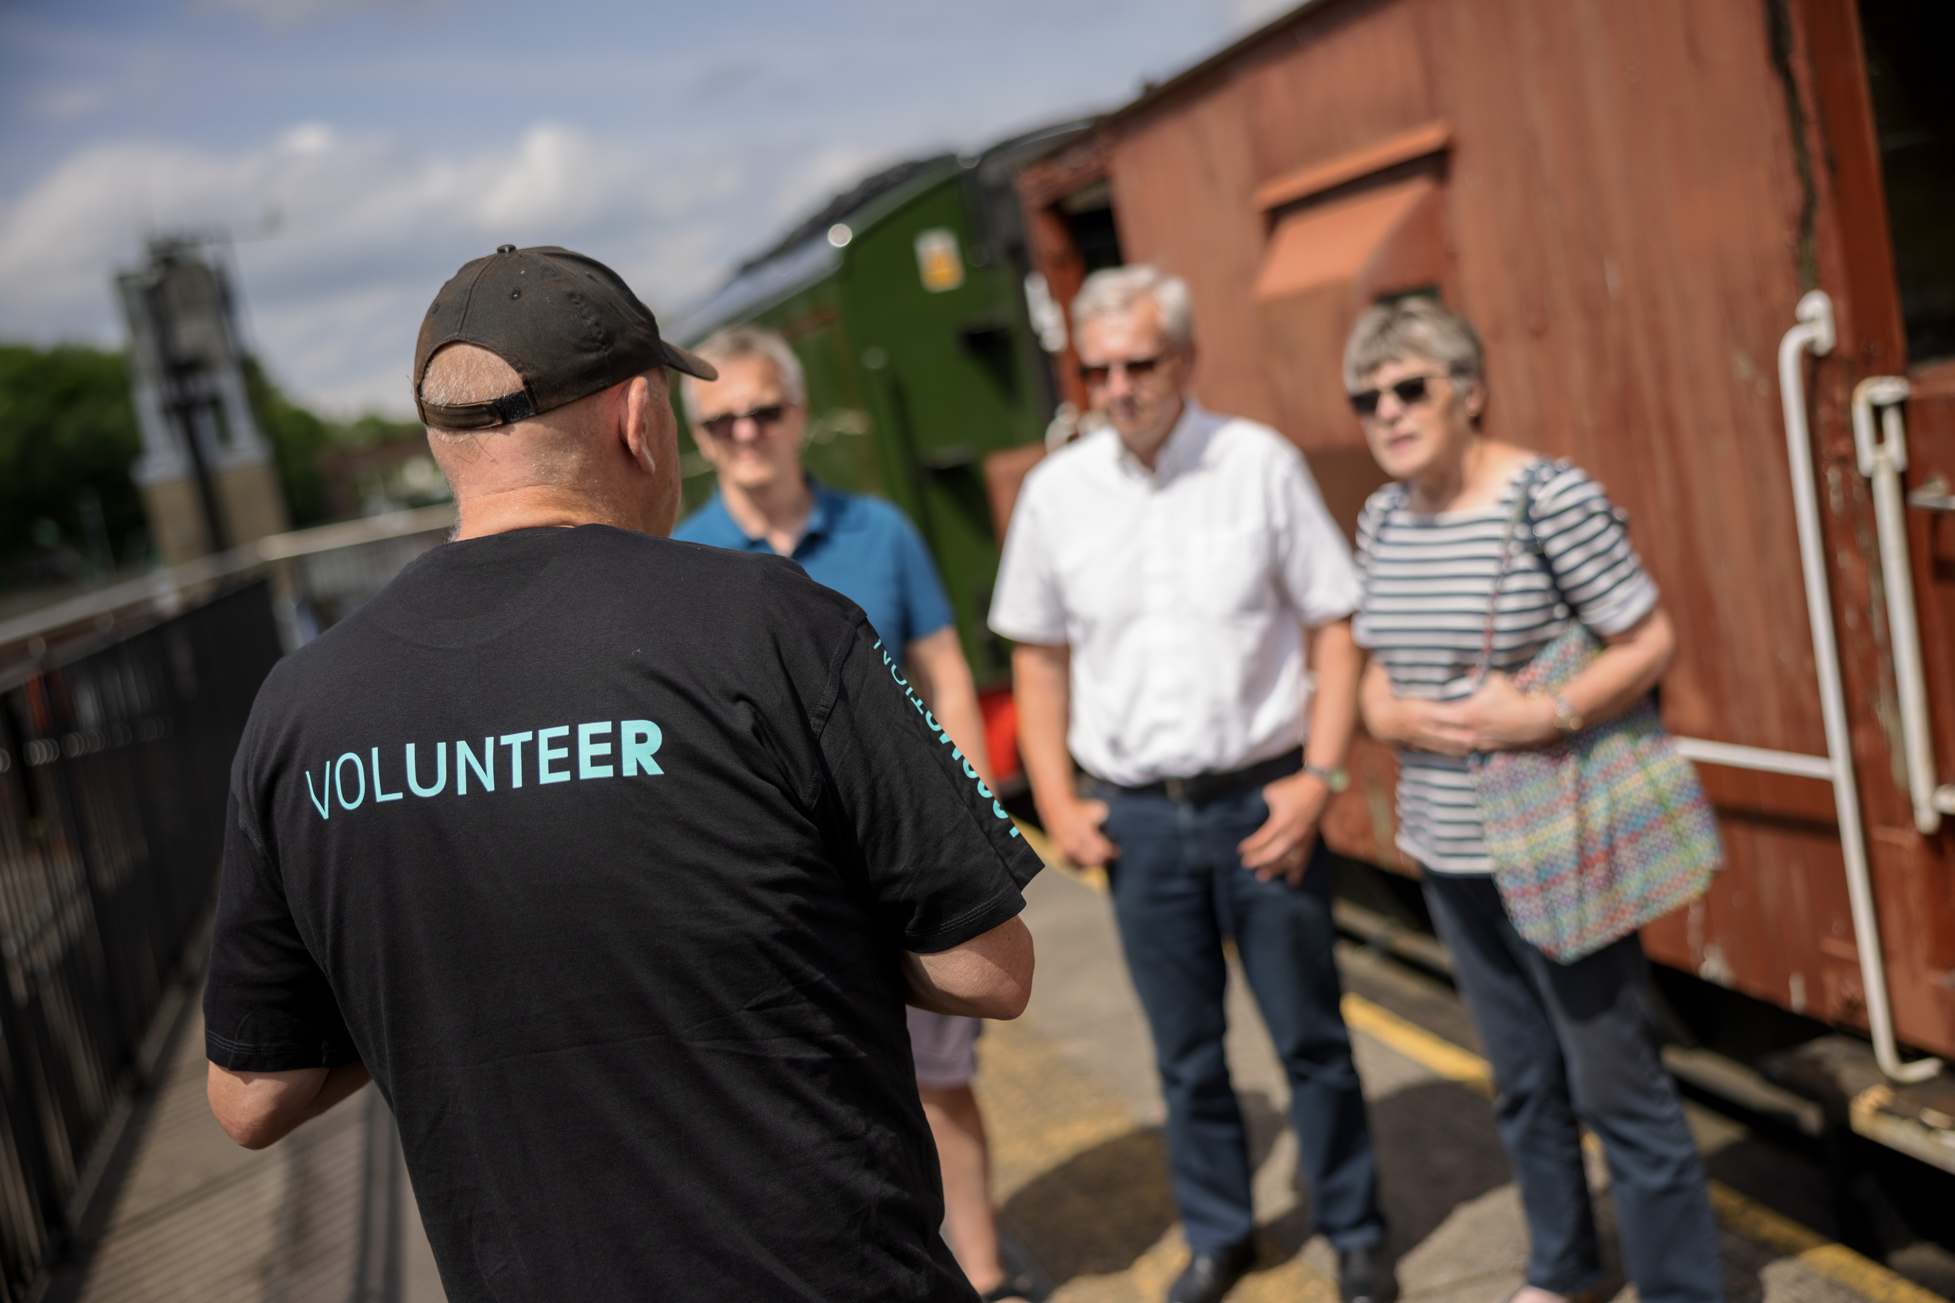**VOLUNTEER ROLE DESCRIPTION**

**VISITOR AMBASSADOR**

Location: Locomotion, Shildon

Hours: 10.00-16.00 (flexible)

Start Date: July 2025 – September 2025

**Inspire our visitors!**

As a Visitor Ambassador volunteer, you will help ensure that all visitors have an enjoyable time with us during our Summer Celebration. You will be the friendly and welcoming face of the museum, sharing the knowledge that you will learn about our collection, facilities, visitor journey and how we’re commemorating the 200th anniversary of the modern railway.

During this exciting year of railway celebrations, you will be part of a supportive team of colleagues, gaining customer service experience and building your confidence in a stimulating environment. You will help greet visitors, anticipate and respond to their needs, and listen to their feedback.

We ask our Visitor Ambassadors to commit to short sessions of 2-3 hours at a time as often as they are able between July and September. Seating can be provided.

In this role you’ll:

* + - * Be the friendly face of the museum, ensuring all visitors feel welcome
      * Assist with the flow of visitors into the museum and steward our exhibition spaces
      * Share insights and stories related to the collection
      * Be informed of all facilities, events and exhibitions taking place across the site, and actively promote these to enhance the visitor experience and encourage repeat visits
      * Answer visitor queries or seek the assistance of those who can do so
      * Provide feedback and advice on the daily activities of the museum and the visitor experience

If you need help with your application or would like to talk to us about what we can do to support you through this process, please email Katrina at [volunteer.nrm@railwaymuseum.org.uk](mailto:volunteer.nrm@railwaymuseum.org.uk) or call 01904 686248.

**What you’ll get from volunteering:**

We want to ensure you have a rewarding experience with us. That’s why we’ll provide:

* An opportunity to develop skills and enhance your CV.
* Our Inspiring Service Training to help you develop your customer service skills.
* A chance to meet new people and make friends.
* Travel expenses up to £7.
* A reference upon request for all volunteers who have supported the museum.
* An opportunity to make a difference to our museum.

**What you’ll br****ing to the role:**

This role is perfect for people who:

* Enjoy collaborating with volunteers and staff as part of a supportive team.
* Have an enthusiastic approach to delivering a positive visitor experience.
* Are eager to learn about our museum and event programme and are able to communicate this information clearly to visitors.
* Demonstrate an ability to understand and follow safety procedures

We ask all volunteers to show inclusive behaviours, valuing everyone’s contribution, and promoting a culture of openness.

**Key dates:**

* Volunteer Induction: Monday 30 June & Saturday 5 July (attend one day only, please specify availability in application)
* Inspiring Service Training: Friday 11 July

**Additional information:**

* To volunteer in this role you must be 18 or over.
* If successful we’ll request a basic criminal record check. We’ll arrange and process this for you and will cover all the costs. Any issues raised in the check will be considered on a case-by-case basis.
* We are legally required to ensure all volunteers from overseas have the right to volunteer in the UK, so please check your visa before applying.
* Visit [locomotion.org.uk/about-us/volunteering](https://www.locomotion.org.uk/about-us/volunteering) for more information.

**How to apply**

We believe in a culture that recognises and values different experiences, mindsets, and expertise and welcome applications from all backgrounds. You can apply for this position via our [careers site](https://www.sciencemuseumgroup.org.uk/work-with-us). Please answer the following questions in the Supporting Statement section of the application form.

1. Why are you interested in volunteering with us as a Visitor Ambassador?

If you have any questions about the role, please call Katrina, Volunteer Manager, on 01904 686248 or email [volunteer.nrm@railwaymuseum.org.uk](mailto:volunteer.nrm@railwaymuseum.org.uk)