Befriender Volunteer Application Form

Name |  |  |  |  |  |  | D.O.B
Address
Postcode |  | Age |  | Email
Telephone |  | Mobile |  |  |  | Landline 01

1st Language English 2nd Language Choose an item.

Gender Choose an item. Ethnicity Choose an item.

Religion Choose an item. Sexual Orientation Choose an item.

REASON FOR WANTING TO VOLUNTEER

2 X REFEREES

Name 1 |  | Telephone/Email
Name 2 |  | Telephone/Email

Please tick a preferred time slot you are available for a quick chat with a representative from the Together Talks support team. This gives you the opportunity to ask any questions.
AM | PM
Monday | 9:30am – 1pm | ☐ |  | Monday | 1pm -4:30pm | ☐
Tuesday | 9:30am – 1pm | ☐ |  | Tuesday | 1pm -4:30pm | ☐
Wednesday | 9:30am – 1pm | ☐ |  | Wednesday | 1pm -4:30pm | ☐
Thursday | 9:30am – 1pm | ☐ |  | Thursday | 1pm -4:30pm | ☐
Friday | 9:30am – 1pm | ☐ |  | Friday | 1pm -4:30pm | ☐
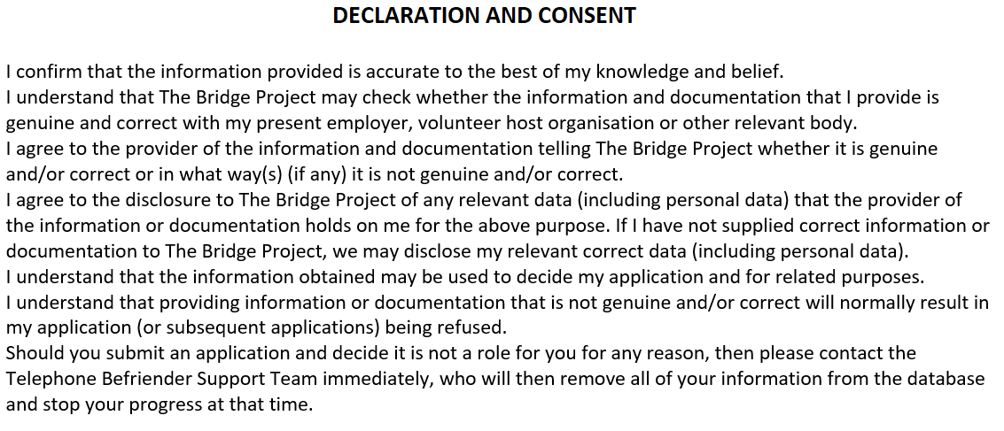
Please cross this box to confirm acknowledgement & understanding of all this document ☐

