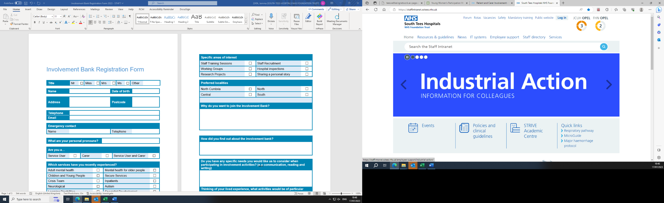
Involvement Bank Registration Form
Title | Mr | ☐ | Miss | ☐ | Mrs | ☐ | Ms | ☐ | Other

Full name |  | Date of birth
Gender |  | Ethnicity
Address
Telephone number |  | Email address
What are your pronouns?

Are you a …  (Please tick all that apply) | Patient | ☐ | Relative of a patient | ☐ | Carer of a patient | ☐

Have you, a relative, or someone you care for used our services in the past 3 years? | Yes | ☐ | No | ☐

Which services have you experienced in the past 3 years? i.e. A&E, Ward 7, Cardiology etc
Why do you want to join the Involvement Bank?

How did you find out about the Involvement Bank?

Select the activities you are interested in. You can change these at any time.
Attending meetings | ☐ | Completing inspections | ☐
Completing surveys | ☐ | Designing surveys | ☐
Designing leaflets | ☐ | Focus/working groups for specific projects | ☐
Giving feedback on new ideas and products | ☐ | Research projects | ☐
Staff recruitment | ☐ | Other ………………………………….. | ☐

Please tell us if you have any communication or accessibility requirements.
Is there anything else you want to tell us?

Do you have access to an electronic device? | Always | ☐ | Sometimes ☐ | No | ☐
Do you have access to Wi-Fi / internet? | Always | ☐ | Sometimes ☐ | No | ☐

Emergency contact (These will only be contacted in an emergency during an involvement activity)
Name |  | Telephone number
Further information (if required)

Declaration
Your details will be kept on a secure database in accordance with the Data Protection Act 2018/GDPR and will not be shared with any other organisation. You can ask the Patient Experience team to remove your details at any time.

Email: stees.involvement@nhs.net
Telephone: 01642 835964
Post: Patient Experience, The James Cook University Hospital, Marton Road, Middlesbrough
TS4 3BW
Signature |  | Date

Please return forms to stees.involvement@nhs.net or Patient Experience, The James Cook University Hospital, Marton Road, Middlesbrough, TS4 3BW.

