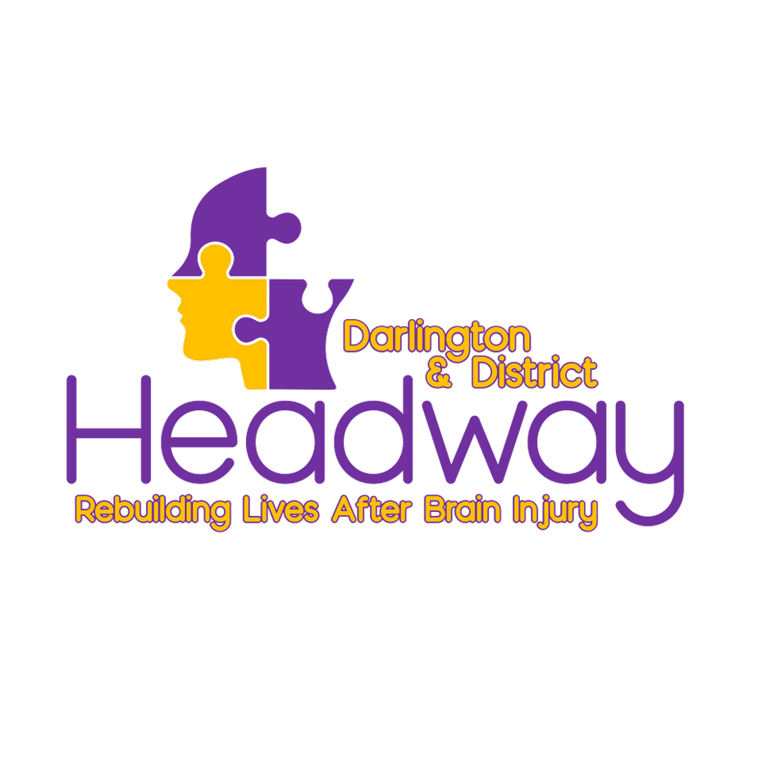
Volunteer Information & Application Pack
Updated December 2024.

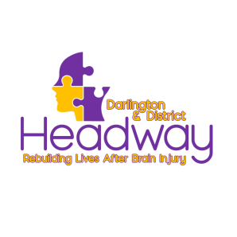

Headway Darlington & District:
Background to the organisation
Headway Darlington & District is an independent registered charity that was formed in 2013 by relatives of brain injured people and professionals.
It is now one of over 100 Headway groups throughout the U.K. and is affiliated but not funded by the national organisation Headway – the brain injury association.

Our Mission

Is to promote understanding of all aspects of brain injury for both individuals and the wider community via support, advice and educational services.

Our Vision

By providing the support, advice, and education to our brain injury survivors we hope to improve the outcomes for the individual, the family and the wider society affected by the life changing impact of brain injury.

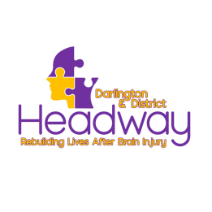
The Headway Hub

Our Headway Hub is based in central Darlington and provides a meeting place as well as facilities for improving social, domestic and educational skills. With the right help and support, progress and improvements can be made by people with acquired or traumatic brain injury for years after the injury has occurred.

Families and Carers

Caring for someone with a brain injury can be difficult. Therefore, we offer support to the whole family with plans to expand this in the future.

Our Members

Referrals
Clients may be referred to Headway by hospital staff, other health care professionals, rehabilitation centres, social workers, lawyers, relatives, or by themselves.

Potential clients will be assessed and advised what support we feel would benefit them. All new members can access our services for free. We do however ask for a donation of up to £10 per month as a contribution towards our running costs and expenses but this is entirely discretionary.

Moving on
Where possible, our members are encouraged to participate in activities of their choice outside Headway, to pursue work opportunities in a voluntary or paid capacity if appropriate and in some cases resume their former employment. Several former Members are currently volunteering with Headway Darlington and District or external charities. Members often remain in contact with the charity at any time after they have left.

Confidentiality
All Staff, Volunteers and Trustees are required to respect the confidentiality of information they may be learn in respect of other members, staff or volunteers.

Volunteer Recruitment Policy

Headway Darlington values people who freely give of their time and expertise to the charity. The charity could not function the way we do without our volunteers’ invaluable contribution.

We respect and protect the welfare and rights of our volunteers, staff and members. Accordingly, we have clear guidelines and policies regarding the recruitment, support, and training of volunteers. A copy of these will be provided as part of your induction and training.

Recruitment and Selection Procedure

The recruitment and selection procedure includes completion and submission of an application form, including details of two referees. This is followed by an initial informal meeting at our Headway Hub to inform potential volunteers of the work of Headway Darlington & District and discuss the specific volunteer role identified in more detail.

Finally, recruitment will be subject to suitability, satisfactory references and the volunteer’s desire to proceed. A Disclosure and Barring Service clearance will be carried out.

Training

On completion of the recruitment process ongoing training will be provided as required. Volunteers also receive training on a variety of subjects which are funded by the Charity.
Expenses

Headway Darlington and District will pay reasonable expenses and travel costs but only if previously agreed by the treasurer.

Complaints/Comments Procedure

Headway Darlington & District has a written procedure for complaints and comments. This is available upon request.

Headway Darlington & District look forward to receiving your application form.

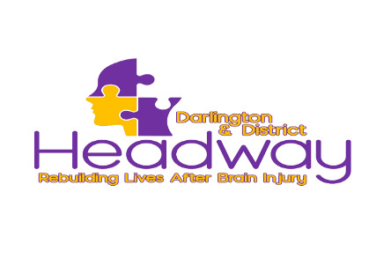
VOLUNTEER APPLICATION FORM
Title | Surname | First Name(s)
Address |  | Mobile Number
 |  | Home Telephone Number
 |  | Email
Postcode
Person to Contact in Case of Emergency |  | Telephone

If you have any illness or disability of which you would like us to be aware, please give details:

Experience
What skills and experience can you bring to Headway?
Previous employment, voluntary work, training, relevant personal experience, interests (brief details please)

Volunteering
Why do you want to be a volunteer with Headway Darlington?

How did you hear about us?

Hours and days available:

Please tick to indicate when you are most likely to be available to volunteer. Please give as many alternatives as possible. Flexible times can be arranged. Please indicate how many hours you might be able to commit to.

 | Monday | Tuesday | Wednesday | Thursday | Friday
AM
PM

Please note we ask a minimum of 1 hour per week or 4 hours per month please confirm you can offer this commitment  Yes I can commit to a minimum of 4 hours per month.

Please give us the names and addresses of two people who can be asked to provide a character reference (these must not be family members). References will not be taken up until after interview.

Name: Name:

Address:

Telephone No: Telephone No:

Email: Email:

Headway Darlington and District aims to promote equality of opportunity for all, with the right mix of talent, skills and potential. We welcome applications from diverse backgrounds.
Disclosure and Barring Service (DBS) check.
Rehabilitation of Offenders Act 1974
The position for which you are applying is exempt from the provisions of the Rehabilitation of Offenders Act 1974 and all convictions, whether spent or not, should be disclosed on this form. Applicants should be assured that the information they give will be kept confidential. The Data Protection Act requires personal information be obtained and processed fairly and lawfully; the information is only disclosed in appropriate circumstances; is accurate, relevant and not held longer than necessary; and is kept securely. Only relevant convictions and other information will be taken into account so disclosure need not necessarily be a bar to obtaining this position.
Have you ever been convicted or cautioned of a criminal offence? Yes/No

Headway Darlington & District is committed to safeguarding and promoting the welfare of adults and young people in need of care and support. Headway Darlington & District expects all staff and volunteers to share this commitment. Therefore, it is imperative that you provide all the relevant information requested for, Headway Darlington & District, to meet this commitment.

Headway Darlington & District is an equal opportunity employer and opposes all forms of unlawful and unfair discrimination or harassment including those based on race, religion or belief, ethnicity, nationality, creed, gender, sexuality, learning ability, physical impairment, mental illness, and age. It is our intention that all volunteer applicants be given equal opportunity and that the selection decisions be based on relevant role factors.

I declare the above information is correct and wish to apply to become a Volunteer for Headway Darlington and District.

Name: ………….....................................................................................................................

Signature: ……………………………………………… Date: …………………………………...................

